Challenge Number: 1010
Played on date: March 20, 2022 Time: 11:30
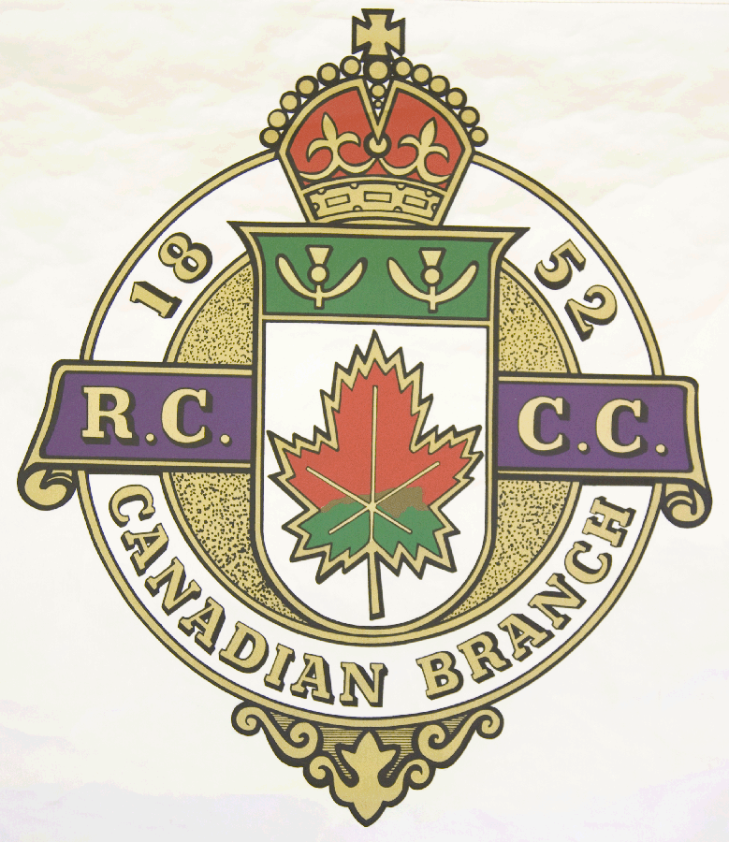
Hosting Club: Metcalfe Curling Club

Host Club Address: 2793 8th Line Road

Host Club City: Metcalfe, Ontario

Host Club Telephone: 613 - 821 - 2335

Host Contact Person: Bill Woods Sr.

Contact phone or email: bill.woods@sympatico.ca

Hosting Club: Metcalfe Challenging Club: Richmond

Skip: WJR Woods Skip: Jim Klachan

Third: Bill Carr Third: Paul Markell

Second: Cory Bekker Second: Mark Schellhorn

Lead: Al McPhee Lead: Wally Kennedy

Skip: WEW Woods Skip: Adam MacFord

Third: Don Chasse Third: Jesse Attfield

Second: Eric Bradbury Second: Bryan Moore

Lead: Niall MacLean Lead: Shawn Westerlaken .

 | Skip | 1 | 2 | 3 | 4 | 5 | 6 | 7 | 8 | 9 | 10 | Score
Sheet  2 | WJR Woods | 1 | 2 | 1 | 0 | 3 | 5 | 0 | 2 | 1 | 0 | 15
Sheet  2 | Klachan | 0 | 0 | 0 | 1 | 0 | 0 | 1 | 0 | 0 | 1 | 3
Sheet  1 | WEW Woods | 1 | 0 | 1 | 1 | 0 | 0 | 1 | 0 | 1 | 0 | 5
Sheet  1 | MacFord | 0 | 2 | 0 | 0 | 1 | 2 | 0 | 2 | 0 | 2 | 9

Hosting club score: 20____ Challenging club score: __ 12____

